1. Read Olson et al., 2019 and see the relationship between Earth rotation rate, surface pressure and upwelling respectively. Also inspect the role of salinity. How could they change under Archean setting?

* Rotation rate↓, upwelling and mixed layer depth↑
* Surface pressure↑, upwelling and mixed layer depth↑
* Salinity↑, upwelling↑, mixed layer depth↓
* Solar irradiation (faint young sun): upwelling optimized at intermediate stellar irradiation, mixed layer depth↓as irradiation↑
* Continental configurations? (Coastal upwelling contributes to global upwelling most significantly)

1. Test run
   1. Calculate residence time (=reservoir volume/min flux rate) of deep ocean water from the global stream function recorded in *biogem_series_misc_opsi.res*. See if compatible with modern observation.

**For a modern ocean volume = 1.302e18 m3 and global overturning flux = -35.636 Sv (106m3/s), deep water age (ocean mixing time) is ~1158 yr. Pretty close!**

* 1. Include red & blue color tracers in user config and visualize total age of deep ocean water by plotting Latitude-Vertical in *misc_col_age* in *fields_biogem_3d*.

Baseconfig: cgenie.eb_go_gs_ac_bg.worjh2.rb

User config: EXAMPLE.worjh2.NONE_colage.SPIN

Spin up to stable state:

$ qsub -j y -o cgenie_log -V -S /bin/bash runmuffin.sh cgenie.eb_go_gs_ac_bg.worjh2.rb / EXAMPLE.worjh2.NONE_colage.SPIN 10000

Run experiments:

$ ./runmuffin.sh cgenie.eb_go_gs_ac_bg.worjh2.rb / EXAMPLE.worjh2.NONE_colage.RUN 10 EXAMPLE.worjh2.NONE_colage.SPIN

**From 2000m to 4000m, ventilation age ranges from ~800-1900 yr (southern ocean much older) and remains constant over time. Consistent with observation/modelling result!**

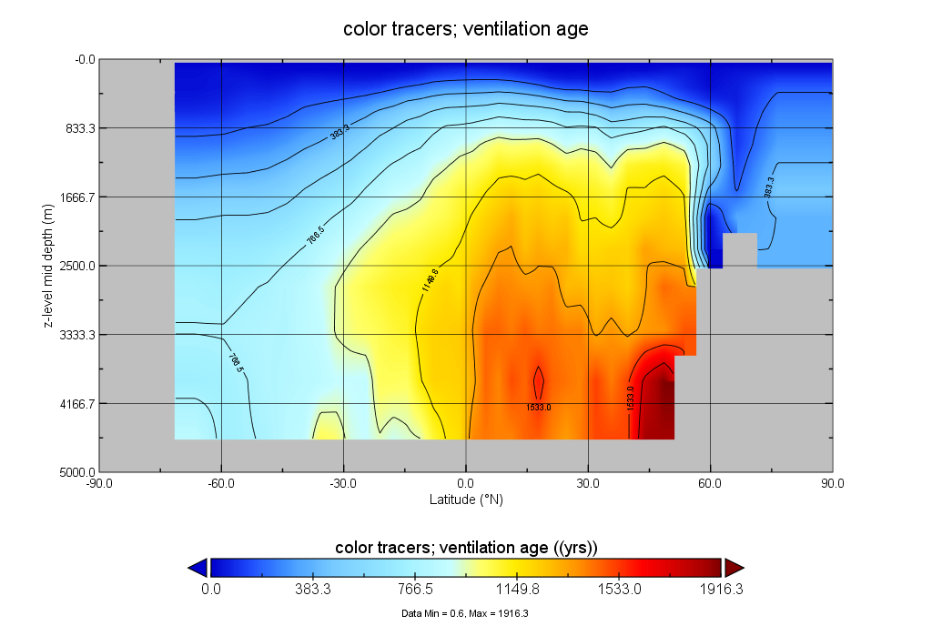

* 1. Enable 14C, 13C, 12C tracers in atmosphere (pCO2, pCH4) and ocean (DIC, CH4), run test and see if we can infer age from the output.

Base config: cgenie.eb_go_gs_ac_bg.worjh2.AGE

pCH4: 13C = -60‰, 14C = 0, 12C = 722E-9 atm

Forcing: pyyyyz.AGE

pCO2: 13C = -6.5‰, 14C = 38.4‰, 12C = 278e-6 atm

*CHECK*: (i) biological scheme, sediments/weathering are consistent with base-config, (ii) time-slice and time-series saving and save options will give you the output you need; (iii) desired tracer forcing(s) are specified (if any)

Spin up to stable state:

$ qsub -j y -o cgenie_log -V -S /bin/bash runmuffin.sh cgenie.eb_go_gs_ac_bg.worjh2.AGE / EXAMPLE.worjh2.AGE.SPIN 10000

Run experiments:

$ ./runmuffin.sh cgenie.eb_go_gs_ac_bg.worjh2.AGE / EXAMPLE.worjh2.AGE.RUN 10 EXAMPLE.worjh2.AGE.SPIN

14C-age = -8267ln(Δ14C/1000+1) (Stuiver and Polach, 1977); Δ14C = benthic DIC_δ14C – surface DIC_δ14C.

**For steady state benthic value = -134.75‰ and surface value = 0.418‰, deep water age is ~1200 yr. Again pretty close!**

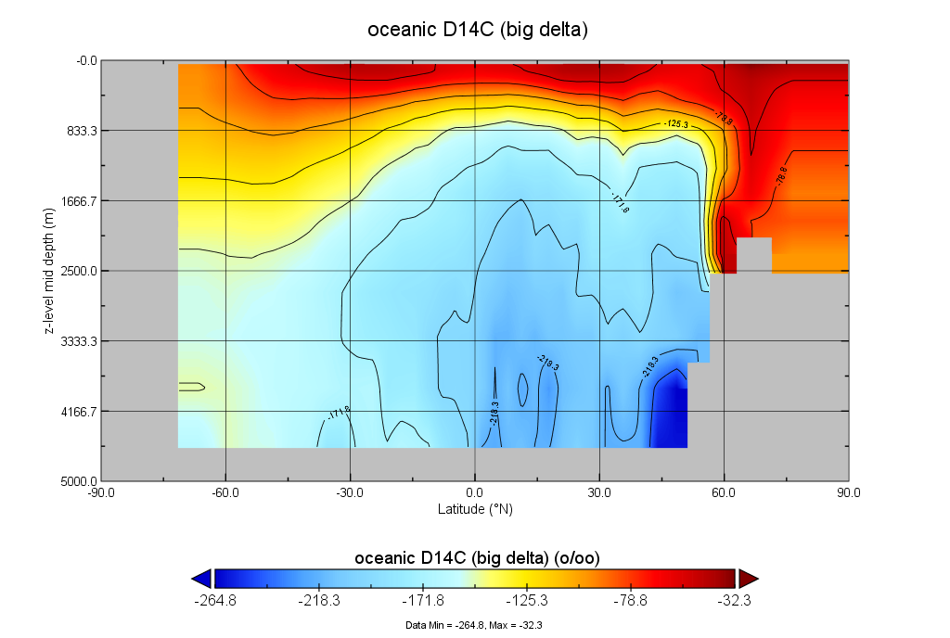

1. If step 2 works, set ranges for uncertain parameters plausible for Neo-Archean setting. Speed up Earth rotation + change continental configuration. Run sensitivity experiments. Find out to which parameters does the ocean respond most sensitively. Run actual experiments using combinations of max & min estimated values of those parameters.

|  |  |  |
| --- | --- | --- |
| Parameter space for sensitivity experiments | | |
| Surface pressure | psurf=0.1, 0.5, 1, 2 | *101100 Pa, PLASIM |
| Salinity | ocn_init_2=20, 35, 50, 70 | PSU, biogem |
| Diapycnal diffusivity | diff-2=0.1, 1, 10 | *0.000135386 m2/s, Goldstein |
| Continental config | world=None (), super (), **modern (igcm16)** | Goldstein |
| Solar day length | 12,15,18,21,24 | Hrs, Plasim, Goldstein, Goldstein-seaice |

For cGENIE

|  |  |
| --- | --- |
| Atmospheric forcing (kept at modern for LPSC) | |
| pCO2 | atm_init_3=2.78E-2 |
| pCO2_13C | atm_init_4=-6.5 |
| pCO2_14C | atm_init_5=38.4 |
| pCH4 | atm_init_10=5E-4 |
| pCH4_13C | atm_init_11=-60 |
| pCH4_14C | atm_init_12=0 |
| Solar constant | 1365 |

./genie.job -f configs/CMPmodern.xml

Definition for parameters in definition.xml (genie-main/src/xml-config/xml/)

**JAN.30**

1. Find a way to replace EMBM with PLASIM in the config files and run model with them.

2. Run a modern scenario first to see if everything works properly.

$ qsub -j y -o cgenie_log -S /bin/bash runmuffin.plasim.sh cgenie.pl_go_gs_ac_bg.igcm16.AOMT / AOMT.igcm16.SPIN 2000

**Feb.2**

Change rotation rate (day length)

1. Use grep to find every instance of 86400 coded in genie.

2. Back up files before changing anything.

3. Add definition of sodaylen =86400 (solar day length) under GOLDSTEIN and GOLDSTEINSEAICE.

4. Change rotation rate for Coriolis effect.

a. Add definition of sidereal_day=86164 (sidereal day length) under PLASIM and sidaylen under GOLDSTEIN and GOLDSTEINSEAICE.

b. Add definition of fsc=4*pi/sidaylen (Coriolis effect scaling factor) under GOLDSTEIN (maybe more).

* Take care of output timestep*:

Plasim has a timestep of 45 min→**24**\*60/45=32 timesteps per day, with 360 model days per year.

Goldstein has a timestep of 720 per year

dstp=ma_genie_timestep (timestep in seconds) =365.25\***24**\*3600/(datmstp*N_TIMESTEPS)=2739.375

**Feb.5**

Change parameter in isolation (10 sensitivity experiments)

* Everything modern (climate kept at modern).
* Change only solar day length to 15, 18, 21 hrs
  + In user config, change solar and sidereal day lengths for pl, go, gs.
  + Create new runmuffin.plasim.sh, change dstp.
* Change only surface pressure to 0.1, 0.5, 2 *modern (101100 Pa)
  + In user config, change pl_psurf.
* Change only salinity to 20, 50, 70 PSU
  + In user config, change go_saln0 and bg_ocn_init_2
* ~~Change only diapycnal diffusivity to 0.1, 10 *modern (0.000135386 m~~~~2~~~~/s)~~
  + ~~In user config, change go_15.~~

#25386

qsub -j y -o cgenie_log -S /bin/bash runmuffin.plasim.sh cgenie.pl_go_gs_ac_bg.igcm16.AOMTM2 AOMTM AOMTM.igcm16.SPIN2 10000

qsub -j y -o cgenie_log -S /bin/bash runmuffin.plasim.sh cgenie.pl_go_gs_ac_bg.igcm16.AOMTM2 AOMTM AOMTM.igcm16.RUN 10 AOMTM.igcm16.SPIN2

#25387

qsub -j y -o cgenie_log -S /bin/bash runmuffin.plasim.sh cgenie.pl_go_gs_ac_bg.igcm16.AOMTM2 AOMTM AOMTM.igcm16.S20.SPIN2 10000

#25388

qsub -j y -o cgenie_log -S /bin/bash runmuffin.plasim.sh cgenie.pl_go_gs_ac_bg.igcm16.AOMTM2 AOMTM AOMTM.igcm16.S50.SPIN2 10000

#25515

qsub -j y -o cgenie_log -S /bin/bash runmuffin.plasim15.sh cgenie.pl_go_gs_ac_bg.igcm16.AOMTM2 AOMTM AOMTM.igcm16.R15.SPIN2 10000

#25518

qsub -j y -o cgenie_log -S /bin/bash runmuffin.plasim18.sh cgenie.pl_go_gs_ac_bg.igcm16.AOMTM2 AOMTM AOMTM.igcm16.R18.SPIN2 10000

#25509

qsub -j y -o cgenie_log -S /bin/bash runmuffin.plasim21.sh cgenie.pl_go_gs_ac_bg.igcm16.AOMTM2 AOMTM AOMTM.igcm16.R21.SPIN2 10000

#25391

qsub -j y -o cgenie_log -S /bin/bash runmuffin.plasim.sh cgenie.pl_go_gs_ac_bg.igcm16.AOMTM2 AOMTM AOMTM.igcm16.P05.SPIN2 10000

#25392

qsub -j y -o cgenie_log -S /bin/bash runmuffin.plasim.sh cgenie.pl_go_gs_ac_bg.igcm16.AOMTM2 AOMTM AOMTM.igcm16.P2.SPIN2 10000

Mar 23-Apr 10: Troubleshoot model for modern run

* Model reached equilibrium but not stability (maybe do an averaged streamfunction).
* Check surface temperature and salinity patterns between two models: not too different.
* ~~Wind stress scaling factor still too large~~: changed to 1, max age was 800 but couldn’t reproduce cGENIE results. Or should we change other subjectively tuned parameters (OHD, OVD, ADRAG, OP1) altogether: changed according to Holden et al 2016’s tuning recommendations with scale_APM=0. Extremely old water trapped in a few deepest ocean grids while the rest of deep ocean is abnormally young. Run 25520 and 25521 have bathymetry fixed (seafloor isolated grid=1 changed to 2).

|  |  |  |  |
| --- | --- | --- | --- |
|  | cGENIE (25631) | Holden (25633) | PLASIM (25632) |
| SCF (go_13, gs_scf) set to 2 (26752) | 1.5310134887695313 | 3.788316 | 2.44653955 |
| OVD (go_15) | **0.000025363247914356** | 0.000158338 | 0.000135386 |
| OHD (go_14) | **1494.4383544921875** | 1936.9958 | 2005.240135 |
| ADRAG (go_16) | **2.7101647853851318** | 2.0686631 ~~(26593)~~ | 2.554625913 |
| OP1 (go_ediffpow1) | **1** | 0.8200495 | 1.077402066 |
| APM (pl_scale_apm/sum(ea_25-27)*scl_FWF) | 0.2326 | 0.2132 | **0** |
| SID (gs_11) | 3573.718017578125 | **15000** | 15000 |
| pl_acllwr | N/A | **0.2** | 0.501520425 |
| pl_albseamax | N/A | **0.4** | 0.449923169 |
| pl_albgmax/ea_par_albsic_max | 0.7 | **0.7** | 0.8 |

Base config: .AOMT: PLASIM setting; .AOMTM: cGENIE setting; .AOMTM2: Holden setting.

User config: AOMT/AOMT.igcm16.SPIN: PLASIM setting; AOMT/AOMTM.igcm16.SPIN: cGENIE setting; AOMTM/AOMTM.igcm16.SPINtest2: Holden setting.

* cGENIE water age is older than the other two but not close to reference age. Though the global stream function looks reasonable enough.
* cGENIE has extremely old water trapped in isolated grid cells below 500m and above 5000m while the other two don’t: ~~fill in those grid cells.~~
* ~~Make a cGENIE default with APM = 0 (to compare with non-modern later) and another with APM = 0.32 (25992). Both crashed after 9990 model year.~~
* Future: trace horizontal mixing by developing a new point tracer (1 in one grid point and 0 everywhere else)
* Use PLASIM parameters, spin 2000 years with gearing (27095) and run 300 years without gearing.

Apr.13-May.8

* Find a way to output Atlantic/Pacific stream function in PC.
* Atlantic bathymetry is limited to northern ocean while Pacific looks fine.
* **“Atlantic calculation hacked so that only the deeper ½ of the maximum is calculated**.”
* **Or maybe it’s because Atlantic overturning crashed in the current setting**?

Day length crashes troubleshooting:

* ~~Fix how color tracer is applied~~
* ~~Done. GENIE measures year length in seconds so days/year needs to be changed for Goldstein and Goldstein sea ice modules.~~
* Analyze impact of gearing ratio on model stability
* A gearing ratio of 1:10 seems to work best here but it doesn’t work when day length is changed so **maybe the modern can work with no gearing after plasim.f90 is modified.**
* ~~How to fix PLASIM calendar for simulations with shorter day length~~
* ~~It crashed with 360 days/year since more years than designated simulation time is required to run to compensate the shorter day length, but it persisted much longer this time.~~
* ~~When both n_days_per_year and n_days_per_month are changed the calendar starts at day 1~~~~st~~ ~~for each month and ends each year after December, but it doesn’t start with January and~~ **~~coupling variables are not reset at the end of a year~~**~~.~~
* Integer/real type error message:

plasim.f90:611.22:

divisor=float(ngear_years_plasim*solar_day/60.)/float(mpstep)

1

Error: 'a' argument of 'float' intrinsic at (1) must be INTEGER

plasim.f90:654.25:

else if (mod(kstep,(ngear_years_plasim*n_days_per_year*solar_day/60./mpst

1

Error: 'a' and 'p' arguments of 'mod' intrinsic at (1) must have the same type

plasim.f90:708.61:

if (mod(nstep+1-(n_days_per_year*solar_day/60./mpstep),nafter) == 0) then

1

Error: 'a' and 'p' arguments of 'mod' intrinsic at (1) must have the same type

* ~~nint(solar_day) fixes the issue but there’s still the floating point error which caused model to crash before next resetting.~~
* Maybe a division of integers results in 0 which is used as a denominator somewhere. 24 should be replaced by int(solar_day).
* ~~Set up a longer day length SE (30 hr).~~
* Run other day length SE to find patterns of when error messages occur: Jobs submitted: 26220-3.

15h ends after July, year 12.

18h ends after Mar, year 9.

20h is wrong too. Timestep is not integral number.

30h ends after Oct, year 6.

* Compare the effect of changing day length and turning on gearing by running 2 groups of SE: compare 26221, 26224 and 26220.

18h tuned ends after Oct, year 1.

* Coupling problem or Goldstein problem?

26360 turns off PLASIM and turns on EMBM with day length = 18h.

* ~~How is seasonality enforced in PLASIM.~~
* ~~Daily insolation cycle can be turned on by ndcycle=1.~~
* ~~For now I can only save BIOGEM data seasonally.~~

May 11-June 6

* Create new continental configuration files
  + For GENIE, use muffingen.
    - Water world: A64x32ww.m
    - Low latitude supercontinent: A64x32ls.m
    - High latitude supercontinent: A64x32hs.m
    - Epicontinental seas: A64x32es.m (copy p0251b.k1)
  + For PLASIM, edit N032_surf_0172.sra and N032_surf_0129.sra

#26327

qsub -j y -o cgenie_log -S /bin/bash runmuffin.plasim.sh cgenie.pl_go_gs_ac_bg.A64x32ww.AOMTM AOMTM AOMTM.A64x32ww.SPIN 10000

#26328

qsub -j y -o cgenie_log -S /bin/bash runmuffin.plasim.sh cgenie.pl_go_gs_ac_bg.A64x32ls.AOMTM AOMTM AOMTM.A64x32ls.SPIN 10000

#26329

qsub -j y -o cgenie_log -S /bin/bash runmuffin.plasim.sh cgenie.pl_go_gs_ac_bg.A64x32hs.AOMTM AOMTM AOMTM.A64x32hs.SPIN 10000

#26330

qsub -j y -o cgenie_log -S /bin/bash runmuffin.plasim.sh cgenie.pl_go_gs_ac_bg.A64x32es.AOMTM AOMTM AOMTM.A64x32es.SPIN 10000

* Why asymmetry?

Run 1 WW SE with temp0=5 and temp1=0 (26591) and 1 WW SE with temp0=0 and temp1=5 (26592) to see if it gives opposite age distribution.

Run all 3 experiments (26753-5) again with 0 eccentricity to see if SH still has colder winter and warmer summer.

Turn obliquity to 0 as well (26938-26940). No difference in age distribution.

* Look up diapycnal diffusivity
  + How is that described in the model? What final equation can we get?

From ediff.F, a stratification-dependent mixing scheme:

*ediff1p = ediff0 + (diff(2)-ediff0)*ediffk0^ediffpow1*(dzrho_lev/dzrho)^ediffpow2,*

where ediff1p is implemented diffusivity; ediff0 is background diapycnal mixing (0 by default); ediffk0 is a reference diffusivity profile exponentially growing with depth and equal to 1 at 2500m; ediffpow1=1 yields an e-folding scale of 700m; dzrho is density gradient; dzrho_lev is density gradient profile; ediffpow2=1 yields constant PE production in diapycnal mixing; diff(2) is diffusivity at 2500m when dzrho=dzrho_lev.

*ediff1(i,j,k)=ediff1p(k)*(1+ediffvar*(ediffvargrid(i,j,k)-1)),*

*diffv=ediff0+ediff1(i,j,k)*(-rdzrho).*

* + κdp in Oliver & Edwards 2008 = diff(2)-κ0 in GOLDSTEIN. κ0 = 0e-5 m2/s by default but = 0.1 cm2/s in O&E.

Figure: density field and meridional streamfunction in the GENIE‐1 coupled climate model for experiments with κdp = 1 (control) or 5 (high Atlantic PE) cm2 s-1.

* + How to estimate diff(2) as a function of Earth-Moon distance?

$κ=\frac{Γε}{{M_{ocn}N}^{2}}$, where $N^{2}=-\frac{g}{ρ_{0}}\frac{∂ρ}{∂z}$ and $Γ=0.2$ (Yang et al. 2017). A proportion (~50%) of ε is $tidal dissipation D=$ $\frac{1}{2}rnM_{M}(ω-n)\frac{dr}{dt}$ (Blackledge et al. 2020), where n= $\sqrt{G(M_{E}+M_{M})/r^{3}}$ is the mean motion of the Moon, ω is the Earth’s angular rotation rate. $\frac{dr}{dt}=fr^{-11/2}$ (Bills & Ray 1999), where f = $3\frac{k}{Q}\frac{M_{M}}{M_{E}}R^{5}μ^{1/2}$, where R is Earth’s radius, μ=G(ME+MM), and $\frac{k}{Q}$ can be calculated as a function of age.

* + Read papers that relate tidal dissipation with Earth-Moon distance and come up with a range for Precambrian tidal dissipation.

Combing the above equations gives D = $\frac{3}{2}R^{5}\frac{{M_{M}}^{2}}{M_{E}}μ\left(ω-n\right)r^{-6}\frac{k}{Q}$.

Taking r and k/Q from Bills & Ray 1999 Fig.2, assume modern ω and observed N2 = 2.98×10-6 s-2 (Griffiths & Peltier 2009):

|  |  |  |  |  |
| --- | --- | --- | --- | --- |
|  | r (106 m) | k/Q (*0.0256) | D (TW) | (m2/s) |
| Modern | 384 | 0.986 | 3.18 | 2.03E-4 |
| 1 Ga | 350 | 0.777 | 4.34 | 2.77E-4 |
| 1.6 Ga | 330 | 0.675 | 5.35 | 3.42E-4 |
| 2.5 Ga | 300 | 0.486 | 6.77 | 4.33E-4 |
| 2.8 Ga | 280 | 0.391 | 8.19 | 5.23E-4 |

Although Webb 1982 used a simplified configuration (hemispherical ocean), a correction factor has been applied to M2 tide in this figure to compare the model estimates with estimates made for present oceans. So it’s reasonable to regard Webb’s D at present as the modern measured D.

Or, substituting Webb’s D by M2 in the ocean (line b) directly into $κ=\frac{Γ*(0.26D+wind)}{{M_{ocn}N}^{2}}$:

|  |  |  |  |  |  |
| --- | --- | --- | --- | --- | --- |
|  | D (TW) | D (TW) with supercontinent | (m2/s) w/ model wind | (m2/s) w/ supercontinent | **(m2/s) combined** |
| Modern | 3.73 | - | 3.18E-5 | - |  |
| 1 Ga (**Pannotia** formation-extroversion) | 2.43 | 0.3, 1, 1.1*PD | 1.83E-5, 2.31E-5, (2.88E-5) | 1.82E-5, 6.06E-5, 6.66E-5 | **6.99E-6,**  **2.31E-5,**  **3.04E-5** |
| 1.6 Ga (**Rodinia** formation - introversion) | 2.50 | 0.3, 1, 2.3*PD | 1.88E-5, 2.36E-5, (2.92E-5) | 1.87E-5, 6.23E-5, 1.43E-4 | **7.13E-6,**  **2.36E-5,**  **5.09E-5** |
| 2.5 Ga (**Columbia** formation) | 5.92 | 0.2, 1, 2.2*PD | 4.16E-5, 4.64E-5, 5.20E-5 | 2.95E-5, 1.48E-4, 3.25E-4 | **1.00E-5 (26799),**  **4.64E-5,**  **9.94E-5(26801)** |
| 2.8 Ga (**Kenorland** formation) | 7.61 | 0.2, 1, 2.2*PD | 5.29E-5, 5.78E-5, 6.33E-5 | 3.79E-5, 1.90E-4, 4.17E-4 | **1.23E-5,**  **5.78E-5(26800)**,  **1.24E-4** |

* + Need to consider how wind contribution changed over time.

“The rate of work done by the wind on the ocean is the force times displacement per unit time, τ ·ug and which, when spatially and temporally integrated, produces an estimate W.”

Wind input (TW) = sum((τu · u + τv · v) · grid area)/1e12: 1bar = 0.32; 2bar = 0.40; 0.5bar = 0.05.

* + Calculate N2 using simulation output: 5.57×10-6 s-2
  + ~~Make ediff0 = 1e-5 in cGENIE.~~
* Calculate energy input from phys_ocn_diffv results: for each depth below 200 m, multiply κ with N2, calculate weighted average wrt ocean volume: E=0.14 TW, D = 1.42 TW, $κ$ = 1.25E-5 m2/s
* Add geothermal heat flux into sensitivity experiment?
  + Already parameterized in BIOGEM: par_Fgeothermal = 0 W/m2 by default.
  + Geothermal heat flux was higher by roughly a factor of 2.8 at 2 Ga and 3.9 at 3 Ga (Table 1 from Turcotte 1980).
  + Set up two sensitivity experiments to see how much difference it causes.
* 3x geothermal heat brings the ocean circulation time down a little bit.

|  |  |  |
| --- | --- | --- |
| Parameter | Scenarios | Note |
| Salinity (ppt) | 20, 30, 35*, 40, 50 |  |
| Surface pressure (bars) | 0.25, 0.5, 1*, 1.5, 2 |  |
| Day length (hrs) | 12, 15, 18, 22.5, 24* | <24 would crash |
| Diapycnal diffusivity (m2/s) | 2.54e-5, 1.00e-5, 5.78e-5, 9.94e-5 |  |
| Continentality | aquaplanet; modern*; low/high latitude supercontinent;  epicontinental seas | Observed symmetry |
| Geothermal heat flux | Add geothermal heat flux in the scenarios in which ocean circulation is potentially weak. |  |